CS 255 System Design Document Template

UML Diagrams

UML Use Case Diagram
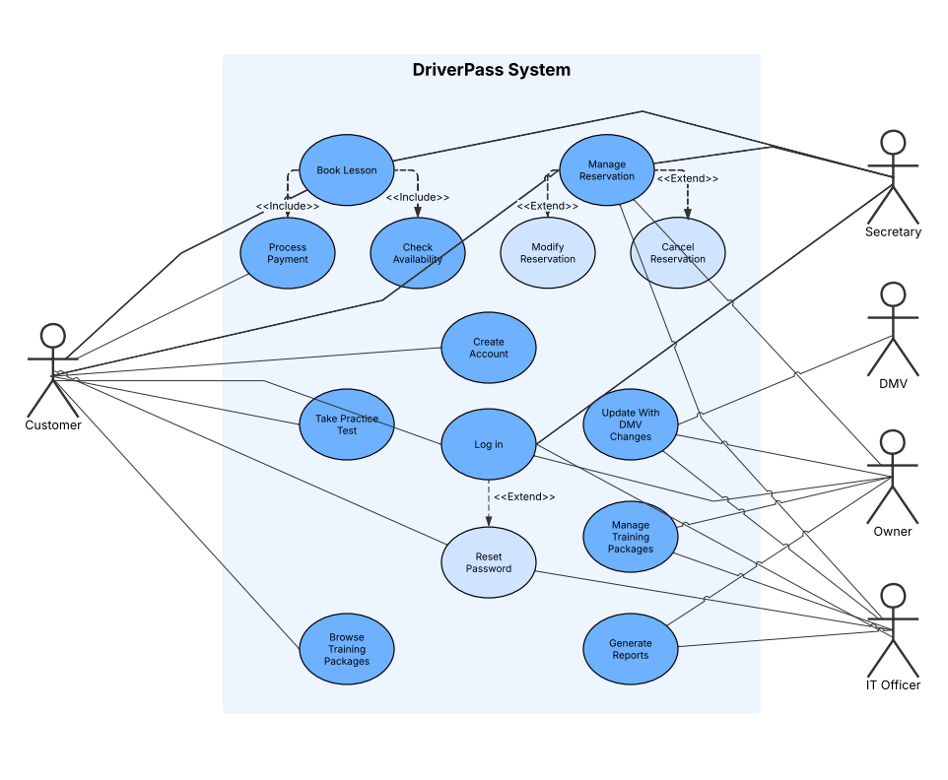

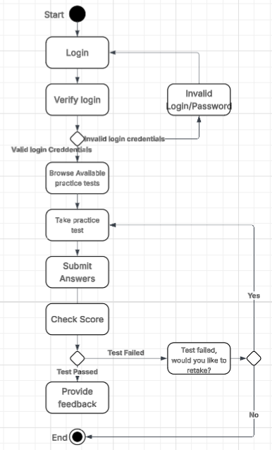
UML Activity Diagrams
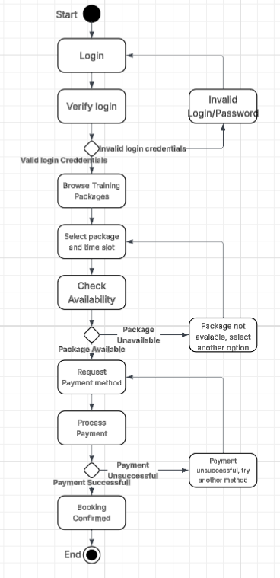

UML Sequence Diagram
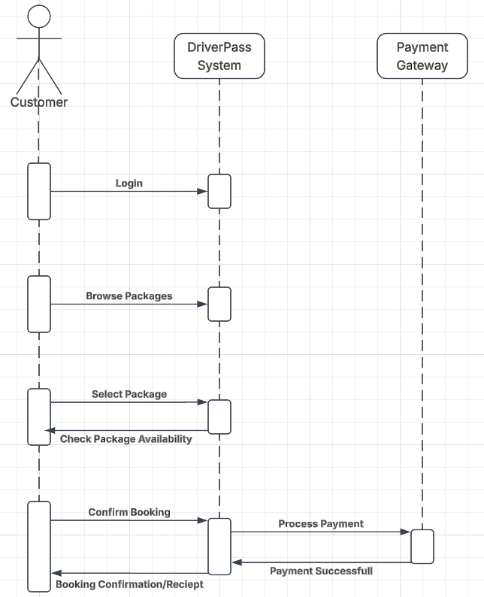

UML Class Diagram
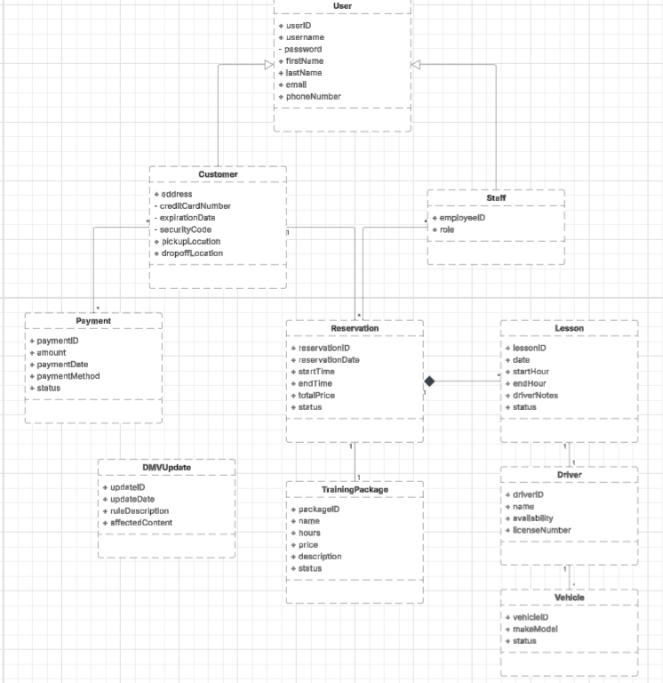

Technical Requirements
The driverpass system needs to have a solid base of a modern, scalable, cloud-based architectural approach that can handle many user types, allow them to book their driving lessons online securely, practice tests, make payments, and deal with administrative tasks.
Hardware

Therefore, the system will be hosted on the cloud (eg aws, azure etc) as opposed to using on premise servers. This provides high uptime/availability and automatic horizontal scaling for multiple users at once. We do, however, require all end clients to have a modern web browser (any Windows/Mac/Linux computer; ios/android smartphone/tablet etc.) to access the client side of the system. Other than these types of devices there's no special hardware required.

Backend:
- Java Spring Boot (.net etc) web app framework, which runs on a Linux-based cloud server (cost-effective/stable).
- Relational database such as MySQL, which stores customer/reservation/trainingpackage/lesson/driver/vehicle information.

Front-end:
- Responsive website interface made up of HTML5/CSS/JavaScript (using React, etc.). So, it works well in all desktop/mobile web browsers.

Integration:
- Third-party payment gateway (eg stripe/Square) to process credit cards securely, external api/DMV integration to receive updates on rules/tests.
Security:
- HTTPS, RBAC, password encryption, and session management.

Tools & Infrastructure:

- IDE: IntelliJ IDEA/Eclipse (backend); Visual Studio Code (frontend); Android Studio/Xcode (if native mobile apps come later)
- Tools: Lucidchart (UML diagrams); git (version control); Docker/kubernetes (cloud scalability/scaling etc.)
- infrastructure: cloud hosting (auto-scaling/back-up/security etc.). This also allows the design to be accessed online and for some limited offline reporting/download (Excel).

This foundation provides a solid and maintainable basis for the DriverPass system to be secure,
scalable, and accessible from anywhere using any type of device, and meets the DriverPass requirements for functional capabilities related to reservations and DMV compliance.

